PROJECT PLANNING PHASE
Project Planning Template – Product Backlog, Sprint Planning, Stories & Story Points
Date | 4 September 2026
Team ID | ________________
Project Name | Metro Ticket Generating System in ServiceNow
Maximum Marks | 5 Marks

Product Backlog, Sprint Schedule, and Estimation
The product backlog below is prepared for the Metro Ticket Generating System in ServiceNow. The user stories are grouped into two proposed sprints and estimated using Fibonacci-style story points.
Sprint | Functional Requirement (Epic) | User Story No. | User Story / Task | Story Points | Priority | Team Members
Sprint-1 | Service Portal & Access | USN-1 | As a user, I can access the ServiceNow Service Portal for metro ticket booking. | 2 | High | ________________
Sprint-1 | Metro Ticket Booking | USN-2 | As a user, I can open the “Book a Metro Ticket” catalog item. | 3 | High | ________________
Sprint-1 | Metro Ticket Booking | USN-3 | As a user, I can enter starting station, destination station, journey type and passenger count. | 3 | High | ________________
Sprint-1 | Validation & Form Behaviour | USN-4 | As a user, I can receive validation for mandatory ticket-booking fields. | 3 | High | ________________
Sprint-1 | Validation & Form Behaviour | USN-5 | As a user, I can use a dynamic form controlled by UI Policies and Client Scripts. | 3 | Medium | ________________
Sprint-1 | Metro Ticket Booking | USN-6 | As a user, I can submit a complete metro ticket request. | 2 | High | ________________
Sprint-1 | Validation & Form Behaviour | USN-7 | As the system, I can validate the journey details before processing the request. | 3 | High | ________________
Sprint-2 | Fare & Request Processing | USN-8 | As the system, I can calculate the applicable metro fare from the journey details. | 3 | High | ________________
Sprint-2 | Fare & Request Processing | USN-9 | As the system, I can process the ticket request using Flow Designer / Process Automation. | 5 | High | ________________
Sprint-2 | Fare & Request Processing | USN-10 | As the system, I can create and store a ticket record for the submitted request. | 3 | High | ________________
Sprint-2 | QR Ticket Generation | USN-11 | As a user, I can receive a unique QR-based digital metro ticket. | 5 | High | ________________
Sprint-2 | QR Ticket Generation | USN-12 | As a user, I can view the generated digital ticket. | 3 | High | ________________
Sprint-2 | Notifications & Verification | USN-13 | As a user, I can receive ticket/request status notifications. | 2 | Medium | ________________
Sprint-2 | Notifications & Verification | USN-14 | As station authority, I can verify a ticket using its QR code. | 3 | High | ________________

Project Tracker, Velocity & Burndown Chart
Sprint | Total Story Points | Duration | Sprint Start Date | Sprint End Date (Planned) | Story Points Completed (as on Planned End Date) | Sprint Release Date (Actual)
Sprint-1 | 19 | 6 Days | Proposed | Proposed | 19 | Proposed
Sprint-2 | 24 | 6 Days | Proposed | Proposed | 24 | Proposed

Velocity:
Total Story Points = 43 (Sprint-1: 19 + Sprint-2: 24)
Number of Sprints = 2
Team Velocity = 43 / 2 = 21.5 Story Points per Sprint
Using the 6-day sprint duration from the planning template, average velocity per day = 21.5 / 6 = 3.58 Story Points per day.
Burndown Chart:
A burndown chart represents the work remaining against sprint time. The chart below is an illustrative planning chart for Sprint-1; actual daily progress can be updated during execution.
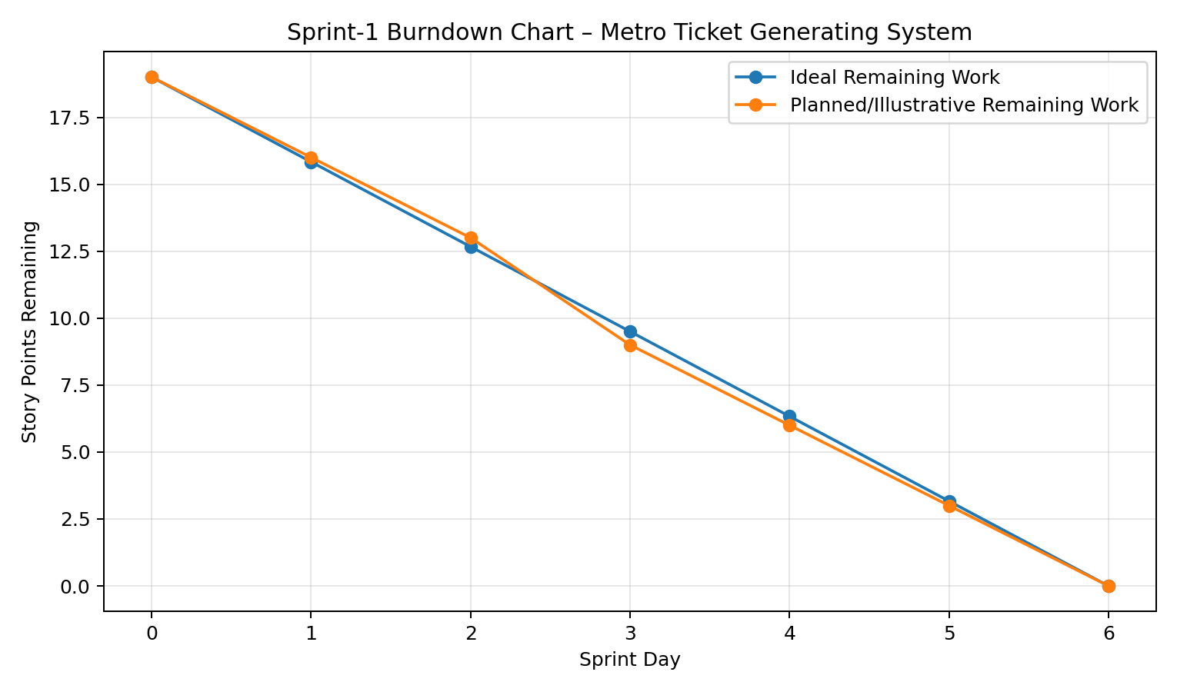
References:
1. Atlassian – Agile Project Management
2. Atlassian – How to do Scrum with Jira Software
3. Atlassian – Epics
4. Atlassian – Sprints
5. Atlassian – Estimation
6. Atlassian – Burndown Charts

